**Installation Guide-ish - DynamicsAXTools Scripts**

1. Download script package from GitHub and extract to a folder. <https://github.com/bferreti/DynamicsAxTools/tree/develop>
2. Run DB creation script DynamicsAXTools\DB\DynamicsAxTools.sql
3. Change Settings.xml DynamicsAXTools\AX-Modules\AX-Settings.xml

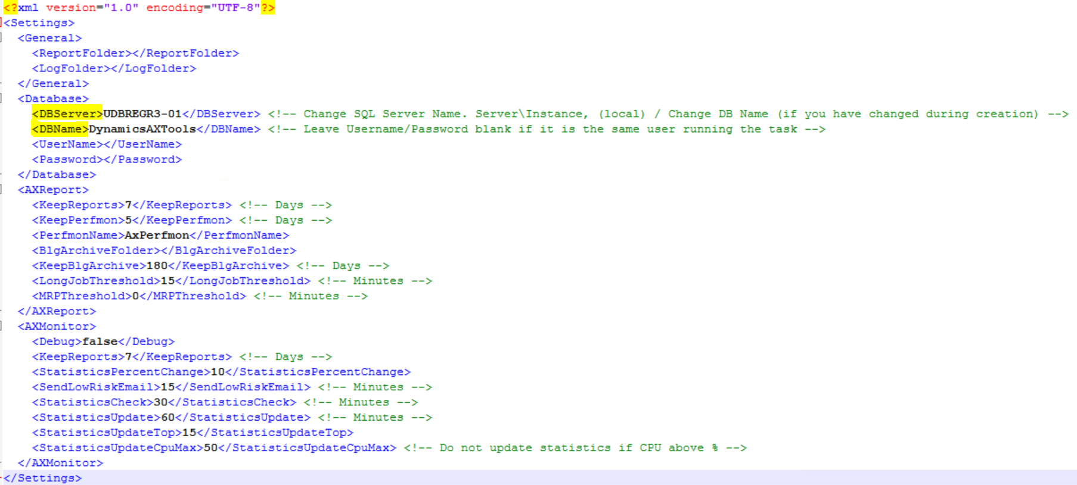

1. Create Environment Configuration

USE [DynamicsAxTools]

GO

INSERT INTO [dbo].[AXTools_Environments]

([ENVIRONMENT]

,[DESCRIPTION]

,[DBSERVER]

,[DBNAME]

,[DBUSER]

,[CPUTHOLD]

,[BLOCKTHOLD]

,[WAITINGTHOLD]

,[RUNGRD]

,[RUNSTATS]

,[EMAILPROFILE]

,[LOCALADMINUSER])

VALUES

('ENV_Name'

,'ENV_Description'

,'SQLServer_Name'

,'AX_Database'

,'UserAccount_AXDB' --If NULL runs as same user running the job

,75 --CPU threshold to trigger script

,15 --Number of blocking to trigger script

,1800000 --Waiting time from a single block to trigger script

,0 --If CPU above threshold script should update statistics

,2 --Run regular update statistics based on seetings. 0-Not run/1-Log statistics info but not run/2-Log and run.

,'EmailProfileID' --Configuration from AXTools_EmailProfile

,'LocalAdminUserAccount_AXServers' --Access to gather information from servers, if NULL runs as same user running the job

)

GO

1. Create Environment Servers

USE [DynamicsAxTools]

GO

INSERT INTO [dbo].[AXTools_Servers]

([ENVIRONMENT]

,[ACTIVE]

,[SERVERNAME]

,[SERVERTYPE])

VALUES

('ENV_Name'

,1 --Server is active 1/0

,'Server_Name'

,'Server_Type' --AOS, IIS, SQL, SRS

)

GO

1. Create Users Accounts (RunAs or Email) DynamicsAXTools\AX-Tools\ AddUserCredentials.ps1

* .\AddUserCredentials.ps1 🡪 Adds a user to AXTools_UserAccount
* .\AddUserCredentials.ps1 -RunAs 🡪 Adds a user to AX-Settings.xml
* Domain Accounts must have DOMAIN\UserAccount

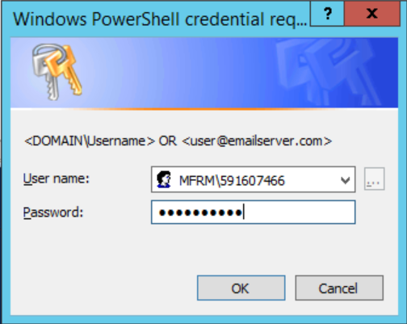

* Email Accounts must have [username@emailserver.com](mailto:username@emailserver.com)

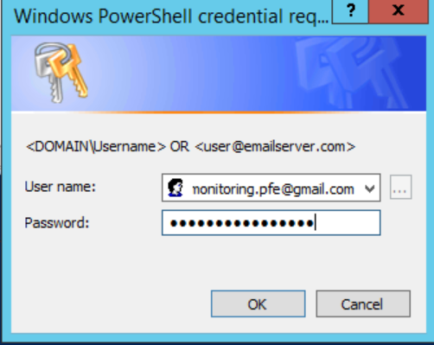

1. Create an Email Profile

USE [DynamicsAxTools]

GO

INSERT INTO [dbo].[AXTools_EmailProfile]

([ID]

,[USERID]

,[SMTPSERVER]

,[SMTPPORT]

,[SMTPSSL]

,[FROM]

,[TO]

,[CC]

,[BCC])

VALUES

('ID'

,'UserID' --ID from AXTools_UserAccount

,'SMTPSERVER'

,'SMTPPORT'

,'SMTPSSL' -- Uses SSL 1 or 0

,'FROM' --Address sending the email (with description)

,'TO' --Separate by ;

,'CC' --Separate by ;

,'BCC' --Separate by ;

)

GO

1. Open Trask Scheduler, to create a task to run script

* Create Task
* General tab
  + Type a Name
  + Change user running task if needed.
  + Check “Run whether user is logged on or not”
  + Check “Run with highest privileges”

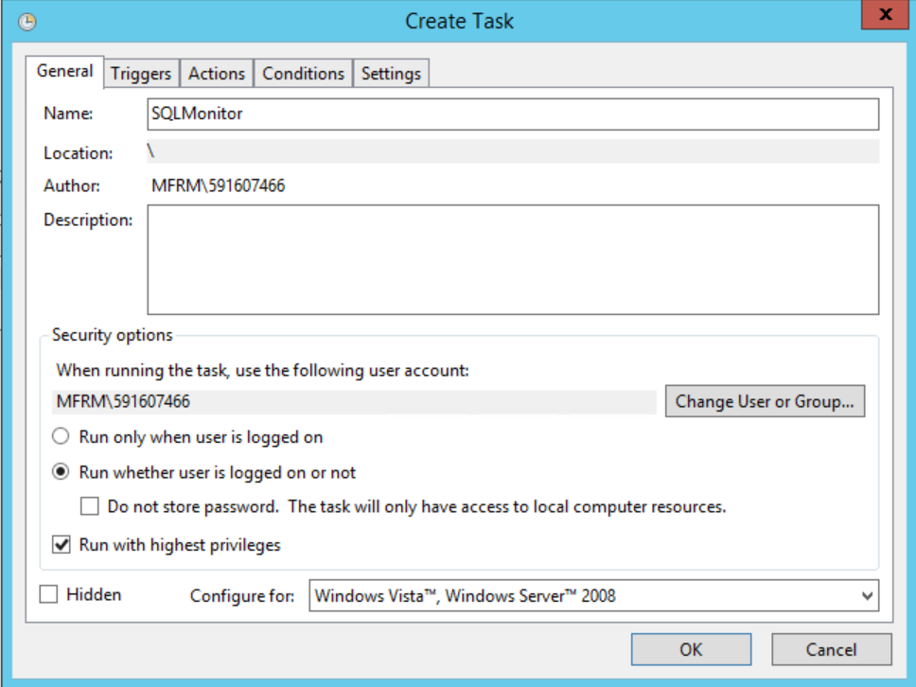

* Triggers tab
  + Click New
  + Check “Repeat task every” *5 minutes* “for a duration of” *Indefinitely*

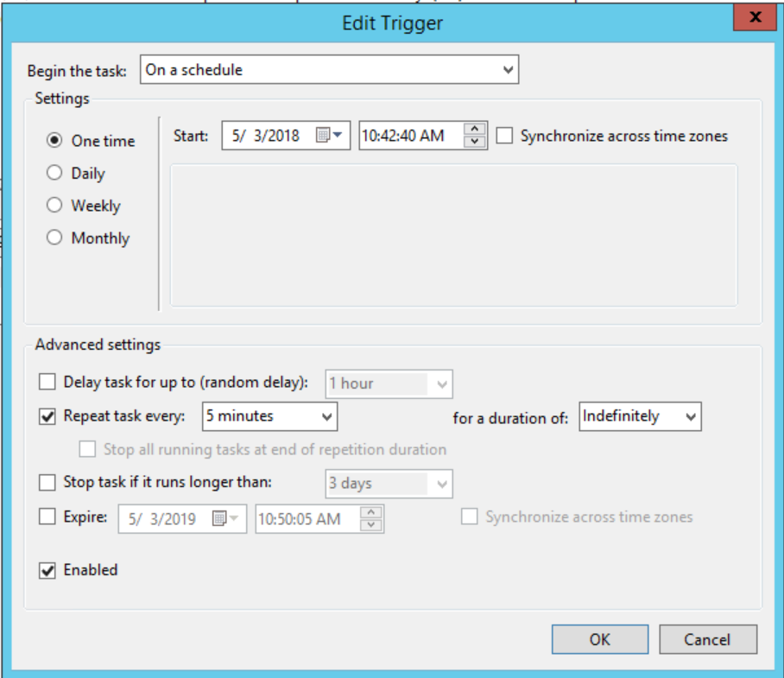

* Actions tab
  + Click New
  + Program/Script type Powershell.exe
  + Add arguments type script path and parameters. D:\DynamicsAXTools\AX-Monitor\AX-SQLMonitor.ps1 -Environment ENV_Name

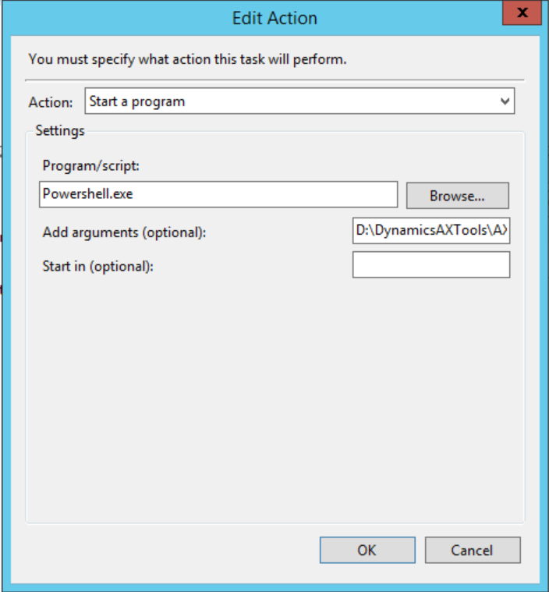

* Settings tab
  + Stop the task if it runs longer than: 1 hour
  + If the task is already running, then following rule applies: Stop the existing instance

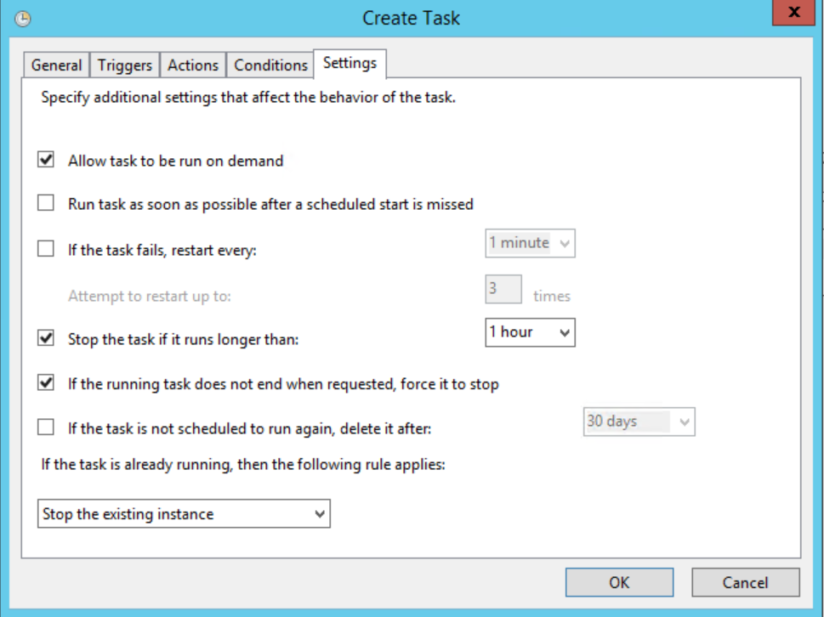



1. Run it and data starts populating ExecutionLog tables.

SELECT * FROM [DynamicsAxTools].[dbo].[AXMonitor_ExecutionLog]



1. If the threshold is met, the script triggers an alert by email and log data to the database.

* If there is no EmailProfile on the environment configuration, the script saves the report locally.



* There’s a EmailLog to keep track of any error sending emails, sent emails and possibly using a third script (depending on customer’s exchange security) to send emails.

SELECT * FROM [DynamicsAxTools].[dbo].[AXTools_EmailLog]

